# Abstract

Use this guide to get started with the syn1588® technology combining a syn1588® PCIe NIC or Dual NIC together with the syn1588® PTP Stack and utilities to setup a PC for PTP clock synchronization.

The syn1588® Linux Live System is a Linux image with the drivers for the syn1588® PCIe NIC and the syn1588® PTP Stack already preinstalled. It is typically included with a syn1588® PCIe NIC or Dual NIC as bootable USB drive (the wooden USB drive).  
If you no longer have access to this USB drive, please contact [support@oregano.at](mailto:support@oregano.at) to get access to the current syn1588® Live System as ISO file.

The syn1588® Linux Live System can be very useful as a quick evaluation tool for our syn1588® hardware and software. Furthermore, the ready-to-use Linux distribution may be installed to a HDD/SSD.

In addition to the syn1588® Linux Live System the image contains the latest syn1588® software and documentation. It includes the most recent version of the syn1588® PCIe NIC drivers and the latest syn1588® PTP Stack and utility applications (e.g., esync) for Linux as well as for Windows.

# syn1588® Life System Content

You may access some of the syn1588® Linux Live System content without booting from the USB drive. This is useful for installing the syn1588® Software Suite on a Windows PC. The following data is available in this way:

|  |  |
| --- | --- |
| Folder | Content Description |
| syn1588 | This folder contains the syn1588® Software Suite release notes and complimentary information about the release.. |
| syn1588/doc | This folder contains the most recent version of the documents, the syn1588® User Guide, a quick start guide and application notes. |
| syn1588/sw | This folder contains all the necessary packages for installing the syn1588 Software Suite on your PC. It also contains starting projects with example applications for the syn1588 API and the shared memory API. |

## Release Notes

|  |  |
| --- | --- |
| Document | Content Description |
| syn1588_release_overview  (RN001) | This document gives a general overview of the current and last releases of the syn1588® Software Suite |
| syn1588_release_roadmap  (RN002) | This document gives an overview of planned features for upcoming sny1588® Software Suite releases. |
| syn1588_release_OS_support  (RN003) | This document gives an overview of the operating systems that are supported by the syn1588® Software Suite. |
| syn1588_software_suite_rn  (RN004) | This document gives detailed information about features/improvements/bugfixes and known issues of the current and past releases. |

## Documentation

|  |  |
| --- | --- |
| Document | Content Description |
| an001_register_map  (AN001) | This application note provides you with a detailed description of the hardware registers of a syn1588® PCIe NIC and Dual NIC, this will be useful for developing your own hardware-level applications. We recommend to use the syn1588® API for easier access to the hardware functionality of the syn1588® PCIe and Dual NIC. |
| an004_syn1588nic_quick_start_guide  (AN004) | This application note provides you with further instructions for installing a syn1588® PCIe and Dual NIC in your own system (Windows or Linux) and setting it up for operation for PTP synchronization. |
| an005_syn1588_system_information_report  (AN005) | This application note gives a short instruction for providing additional data in case of a service request. Please generate and provide the information as described when issuing a request for support to [support@oregano.at](mailto:support@oregano.at). |
| an006_ptp_profiles  (AN006) | This application note describes all IEEE1588 profiles supported by the syn1588® PTP Stack. Furthermore, it gives an overview of syn1588® products that support the corresponding profiles as well as an overview of hardware and software requirements to comply with a particular PTP profile. |
| an007_syn1588_event  (AN007) | This application note describes the capabilities and configuration of the syn1588® event I/Os namely the Trigger output, the Period output, and the Event input. |
| an008_jitter_clean_pll  (AN008) | This application note describes the procedure for using the external jitter-cleaner PLL that can be equipped on a syn1588® PCIe NIC Revision 2 and 2.1 or syn1588 VIP revision 3.0 unit. This PLL can be used to remove the jitter of digitally generated, synchronized clocks. Furthermore it allows generation of high frequency single-ended clock signals (up to 150 MHz). It can also be used (in case of a syn1588® PCIe NIC Revision 2.1) to generate the NIC internal clock from a user-provided input clock. |
| an009_gps_receiver  (AN009) | The syn1588® PCIe NIC and Dual NIC allows the connection of an external GPS receiver that provides the absolute time for IEEE1588 master operations. This application note briefly describes the requirements for selecting an appropriate GPS receiver. |
| an010_syn1588_video  (AN010) | This application note describes how to use the video add-on function available for the syn1588® PCIe NIC. |
| an014_syn1588_NIC_Updater  (AN014) | This application note describes the update procedure of a syn1588® PCIe NIC using the new graphical user interface. With this tool it is possible to upgrade a syn1588® PCIe NIC with a new bitstream file thus ensuring the card is capable of supporting the latest features of the syn1588® PTP Stack. |
| an021_ptp_as_win_service  (AN021) | This application note briefly describes how to run the syn1588® PTP Stack on Windows PCs as service that may be automatically started if the PC is booted. |
| an022_security  (AN022) | This application note describes the use and configuration of PTPv2.1 Security as specified in the 2019 version of the IEEE1588 standard. |
| an034_using_redsync  (AN034) | This application note describes different usage scenarios for the syn1588® redSync utility. |
| an037_cmake_syn1588_ptpstack  (AN037) | This application note provides an overview of the build environment for the syn1588® PTP Stack source code and is also applicable for the syn1588 API and shared memory API sources. |
| an038_syn1588_linux_life_system_quickstart_guide  (AN038) | The application note you are currently reading |
| syn1588_ptp_with_nic_binary | This is the license agreement for use of the syn1588® Software Suite. |
| syn1588_ptpmmm_gui_ug  (UG002) | This is the user guide for the PTP management GUI. |
| ug_syn1588  (UG001) | the general user guide for syn1588® products |

## Installer

### Installers for Linux

The syn1588 Software Suite is delivered in ready-to-use installers for Linux and Windows systems.

To install it on a Linux system, by default to /opt/oregano:

> dpkg -i <chosen deb package>

* Debian package for Linux, without syn1588® GUI applications  
  🡪 ptpv2_linux32bit_*.deb  
  🡪 ptpv2_linux64bit_*.deb
* Archive for Linux binaries, without syn1588® GUI applications  
  🡪 ptpv2_linux32bit_*.tar.gz  
  🡪 ptpv2_linux64bit_*.tar.gz
* Debian package for Linux, with syn1588® GUI applications   
  🡪 ptpv2_linux64bit_*.deb
* Archive for Linux binaries, with syn1588® GUI applications   
  🡪 ptpv2_linux64bit_*.tar.gz

### Installers for Windows

To install it on a Windows system execute the Windows Installer and follow the instructions. You may chose the target location in this installer.

* Windows Installer with syn1588® GUI applications  
  🡪 ptpv2_win32bit_*.exe
* Archive for Windows binaries with syn1588® GUI applications   
  🡪 ptpv2_win32bit_*.zip

The installation will contain the following sub-directory structure:

|  |  |
| --- | --- |
| Folder | Content Description |
| bin | This folder contains the syn1588® Software Suite application binaries |
| etc/ptpv2 | This folder contains example configuration files for different PTP profiles supported by the syn1588® PTP Stack. |
| share/doc/ptpv2 | This folder contains the license for use of the syn1588® Software Suite binaries. |

The following table shows a list of the syn1588® Software Suite applications and a brief description:

|  |  |
| --- | --- |
| Binary | Usage |
| esync / esync.exe | This utility is used for external synchronization to GPS devices or other time sources. |
| fsync /  fsync.exe | This utility is used for configuring a syn1588® PCIe NIC to use external frequency sources or provide frequency to external devices via the jitter cleaner PLL. 🡪 (AN008) |
| lsync /  lsync.exe | This utility is used for local synchronization of different clocks on the local system. For example, syncing the system clock to the hardware clock on an Oregano syn1588® PCIe NIC. |
| ptp /  ptp.exe | This is the syn1588® PTP Stack for version 2 of the PTP protocol |
| ptpmmm / ptpmmm.exe | This utility is used to query PTP-nodes using the syn1588® PTP Management Tool. |
| syn1588 / syn1588.exe | This utility is used to query the registers of a local syn1588® hardware clock on an Oregano syn1588® NIC. |
| redsync / redsync.exe | This utility allows the redundant synchronization of a PTP slave. |
| vsync / vsync.exe | This utility allows the use of external video signals and generation of video signals for external devices. 🡪 (AN010) |

|  |  |
| --- | --- |
| GUI | Usage |
| ptpmmm_gui / ptpmmm_gui.exe | This utility provides a graphical user interface to remotely query PTP data of PTP instances in the network. **This utility cannot be used to query information from a local PTP instance!** |
| update_gui / update_gui.exe | This utility can be used to update the Firmware of syn1588® PCIe NIC and Dual NIC. |

## syn1588® API

The syn1588 API provides you access to the syn1588 PCIe NIC, Dual NIC and IP Core hardware functions, e.g., timestamping packets or external events, generating one-shot or periodic signals.

You can find the syn1588 API and example applications on the syn1588®Linux Live System in the syn1588/sw/export_srcsyn1588API.zip archive.

Follow the guidelines in (AN037) for setting up the CMake build environment for developing your own applications utilizing the syn1588 API.

Follow the guidelines in the .zip archive to get more information about the syn1588 API.

## Shared memory API

The shared memory API provides you access to the syn1588 PTP Stack and utilities during runtime. You can use it to get status information as well as directly interacting with the applications.

You can find the shared memory API and example applications on the syn1588®Linux Live System in the syn1588/sw/export_srcsharedememoryAPI.zip archive.

Follow the guidelines in (AN037) for setting up the CMake build environment for developing your own applications utilizing the shared memory API.

Follow the guidelines in the .zip archive to get more information about the shared memory API.

# Requirements

The syn1588®Linux Live System is based on Ubuntu Linux 20.04.0 (Linux Kernel 5.4). The basic system requirements are the same as for Ubuntu Linux 20.04.

The minimum system requirements are:

* 2 GHz dual core processor
* 4GiB RAM (system memory)
* 25 GB of hard drive space for installation (optional)
* VGA capable of 1024x768 screen resolution

The recommended system requirements

* syn1588® PCIe NIC installed in the system

The syn1588® Linux Life System provides UEFI Boot and Legacy BIOS Boot.

## Install the syn1588® Linux Live System to hard disk

Installing the syn1588® Linux Live System offers some advantages in comparison to booting the syn1588® Linux Live System from the USB drive:

* Keyboard Layout settings are persistent.
* You get a fully working Ubuntu Linux 20.04 System with the Oregano syn1588® PCIe NIC drivers and software preinstalled.
* You do not need the syn1588® Linux Live System USB-Stick to work with your syn1588® PCIe NIC.

The shortcut “Install Ubuntu 20.04” will start the Ubiquity-Installer. The Ubiquity-Installer will guide you through the process of installing the syn1588® Linux Live System to the hard disk of your system.

## Create a bootable USB drive from the syn1588® Linux Live System ISO file

Each syn1588® PCIe NIC or Dual NIC is delivered with a wooden USB drive providing the syn1588® Linux Live System.

If you want to duplicate the USB drive or you lost your USB drive please contact [support@oregano.at](mailto:support@oregano.at). We can provide you with a ISO file for creating your own bootable USB drive with the syn1588® Linux Live System.

To create a bootable USB drive follow this procedure:

1. Download the Freeware “Rufus”  
   🡪 <https://rufus.ie/en_US/>, v3.14.1788 (other versions should work too)
2. Configure Rufus as shown in Figure 1. This is typically the default setting, only the syn1588® Linux Live System ISO file has to be chosen.
3. “START”
4. Select the ISO mode as shown in Figure 2.
5. After a successful operation (typically within 10 minutes) the USB drive will contain the syn1588® Linux Live System and can be used as bootable USB drive.

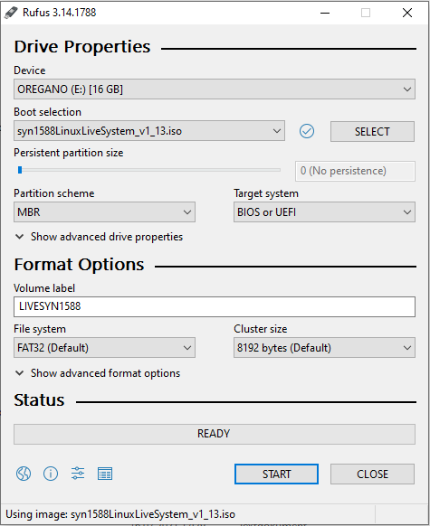

Figure 1: Creating a bootable USB with Rufus, basic configuration

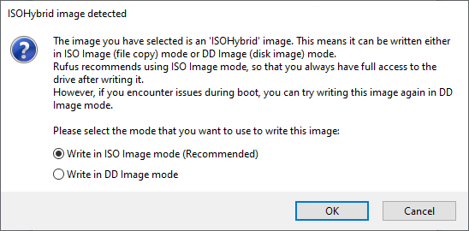

Figure 2: Creating a bootable USB with Rufus, select ISO mode

# Common tasks in the syn1588® Linux Live System

* 3

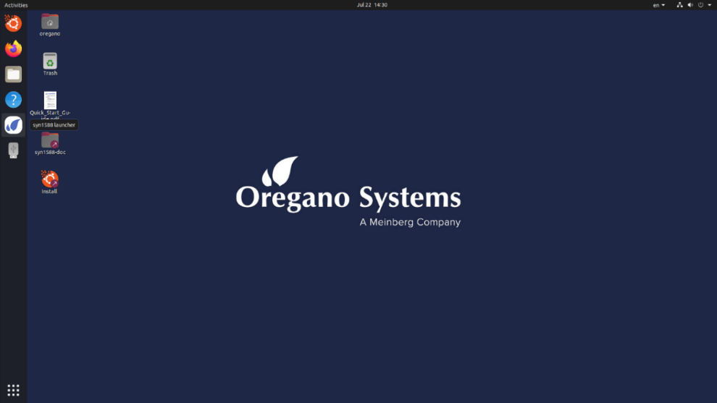

1jkjnk1

1

11

2

1

3

11

4

Figure 3: syn1588® Linux Live System Desktop

This chapter explains some of the most common tasks which can be done in the syn1588® Linux Live System.

1. Green Arrow Figure 3:  
   This document provides a good entry point for use of the syn1588® Live System together with the syn1588® PCIe NIC and Dual NIC.
2. Yellow Arrow Figure 3:  
   The syn1588 launcher can be used to start some of the syn1588 Software Suite applications® for testing basic operation (e.g., testing PTP synchronization). Please follow the guide in chapters 0 to 0 to get more information
3. Purple Arrow Figure 3:  
   Via this icon you can install the syn1588® Linux Live System on your PC. This installation will include the same functionality as the syn1588® Linux Live System itself (e.g., Linux driver installed for syn1588® PCIe NIC and Dual NIC)
4. Red Arrow Figure 3:  
   Follow this link to access the extensive documentation. This will open a file browser for the directory /opt/oregano/doc which contains the syn1588® user guide and various application notes.

## syn1588® Launcher

The syn1588® Launcher is a drop-down menu which will show a list of applications that can be executed. Click on the syn1588® Launcher situated on the taskbar in the left of the screen and a menu will appear. The next chapters describe how to access and run various syn1588® applications via this launcher.

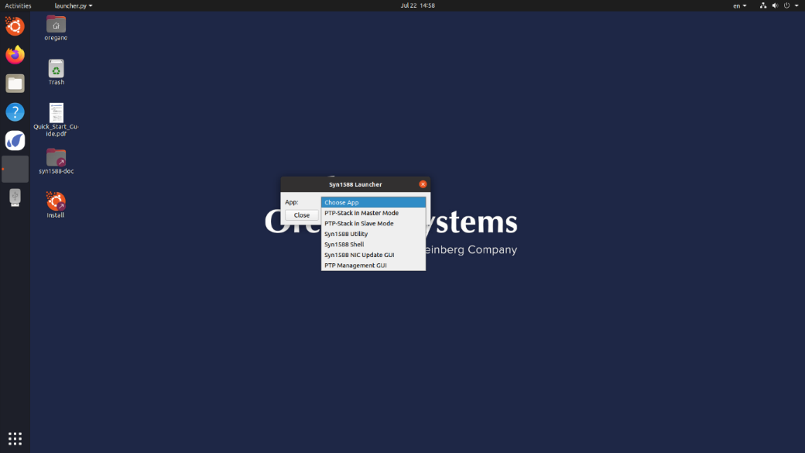

Figure 4 Click on the syn1588Launcher

## Starting a syn1588® PTP Stack with default settings in Master mode

To start the syn1588® PTP Stack with default settings and Master mode:

1. Start the syn1588® Launcher icon situated on the left taskbar. (Figure 4)
2. Click on the “PTP-Stack in Master Mode” in the drop-down menu (Figure 5)
3. Select the desired interface to connect with the syn1588® PTP Stack (

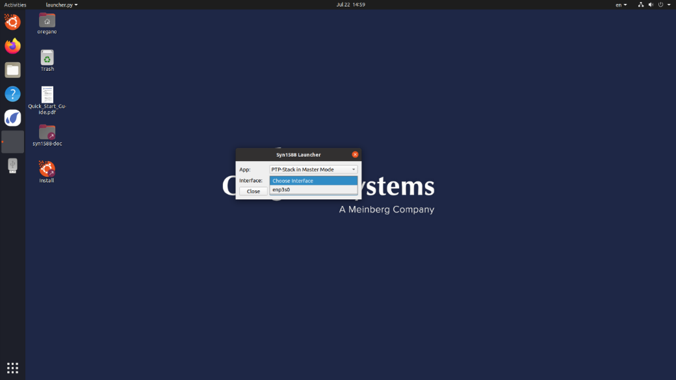

1. Figure 6)
2. Press “Run”
3. A console window will appear which shows the log output of the syn1588® PTP Stack (Figure 7)

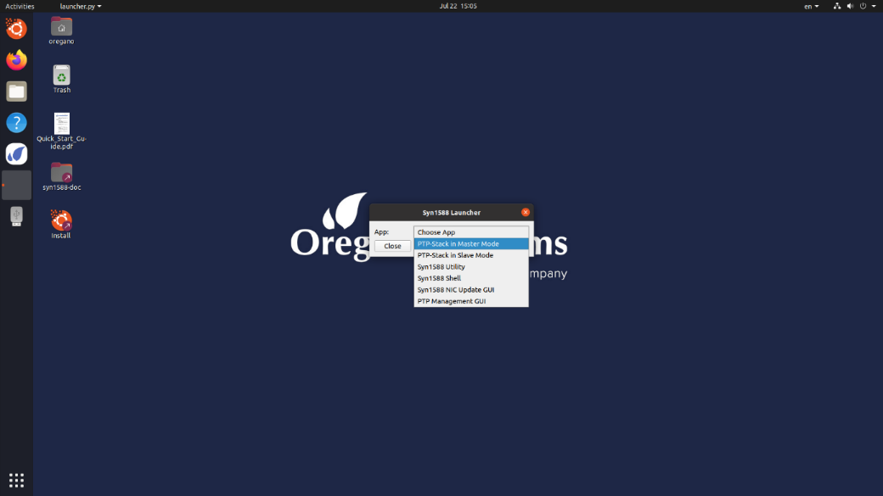

Figure 5 Select to run “PTP-Stack in Master Mode”



Figure 6 Select the desired interface

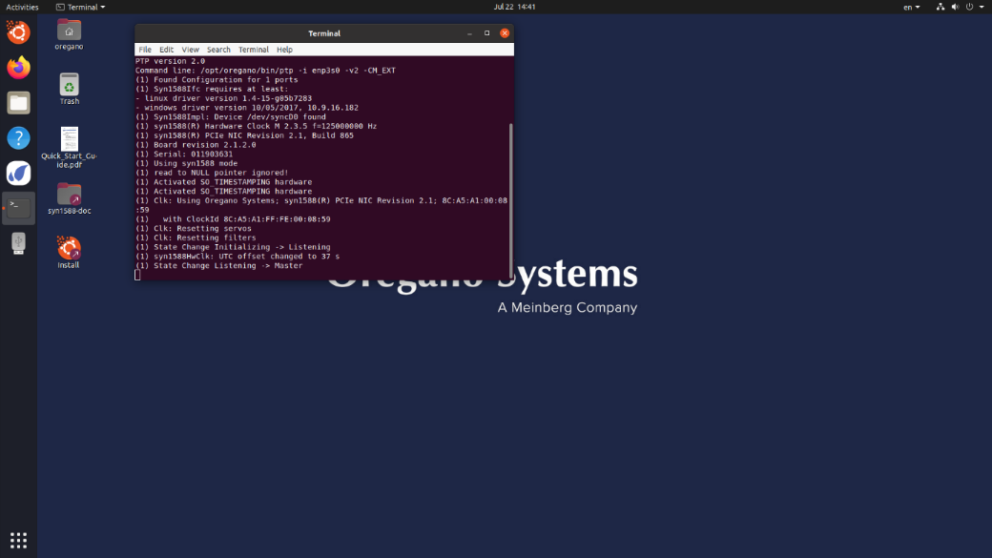

Figure 7 syn1588® PTP Stack in Master Mode running

## Starting a syn1588® PTP Stack with default settings in Slave mode

To start the syn1588® PTP Stack with default settings and Slave mode:

1. Start the syn1588® Launcher icon situated on the left taskbar. (Figure 4)
2. Click on the “PTP-Stack in Slave Mode” in the drop-down menu (Figure 8)
3. Select the desired interface to connect with the syn1588® PTP Stack (Figure 9)  
   Note that this drop-down menu will only list syn1588® PCIe NIC or Dual NIC interface cards!
4. Press “Run”
5. A console window will appear which shows the log output of the syn1588® PTP Stack (Figure 10)

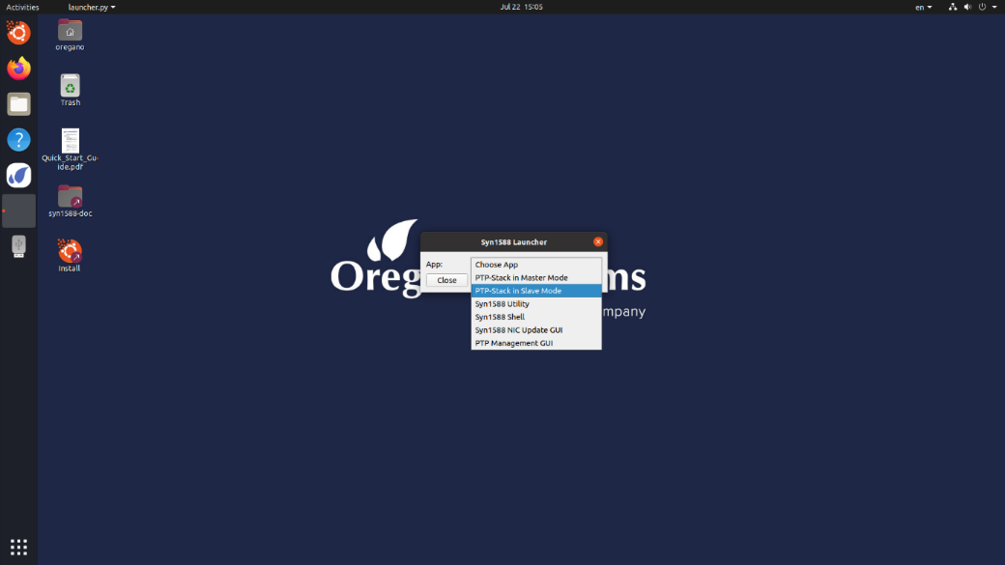

Figure 8 Select to run “PTP-Stack in Slave Mode”

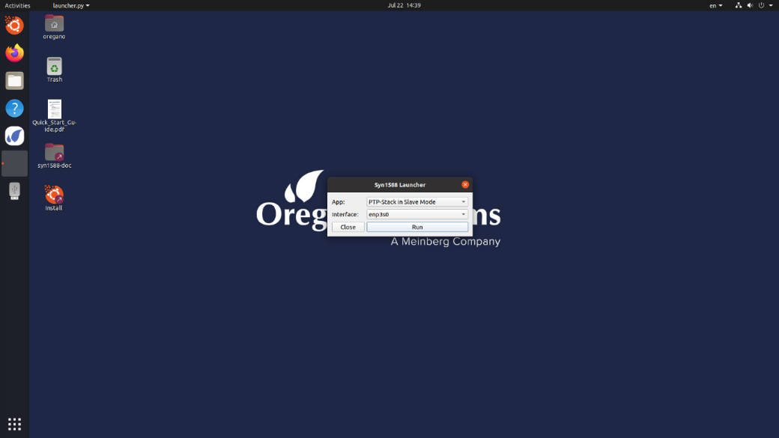

Figure 9 Select the desired interface

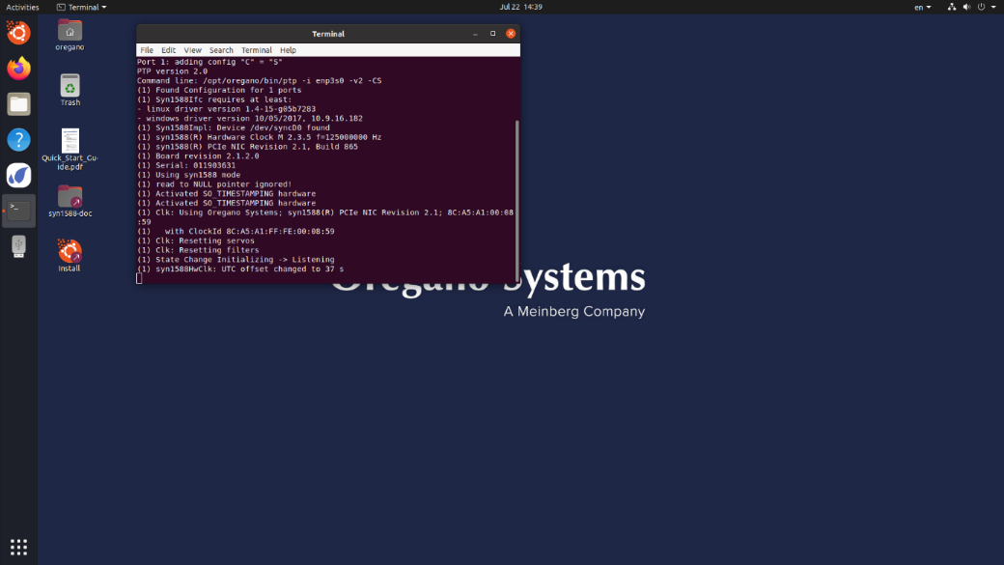

Figure 10 syn1588® PTP Stack in Slave Mode running

## Starting a syn1588® Utility

To start the syn1588® Utility:

1. Start the syn1588® Launcher icon situated on the left taskbar. (Figure 4)
2. Click on the “PTP-Stack in Slave Mode” in the drop-down menu (Figure 8)
3. Select the desired interface to connect with the syn1588® PTP Stack (Figure 11**Fehler! Verweisquelle konnte nicht gefunden werden.**)  
   Note that this drop-down menu will only list syn1588® PCIe NIC or Dual NIC interface cards!
4. Press “Run”
5. A console window will appear which can be used to interact with the syn1588® Utility (Figure 12**Fehler! Verweisquelle konnte nicht gefunden werden.**)

The syn1588® Utility can be used to access the syn1588® PCIe NIC or Dual NIC on register level and to use a subset of syn1588® API functions from the command line. Refer to the help output of this utility and the syn1588 user guide for more information.

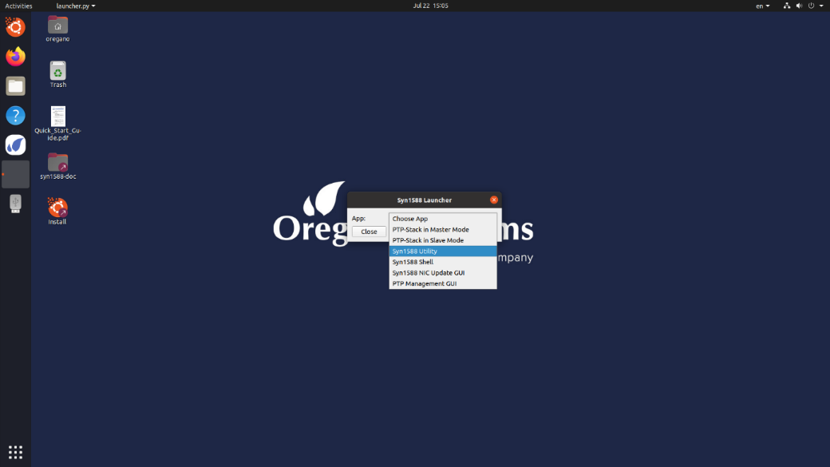

Figure 11 Select to run the syn1588® Utility

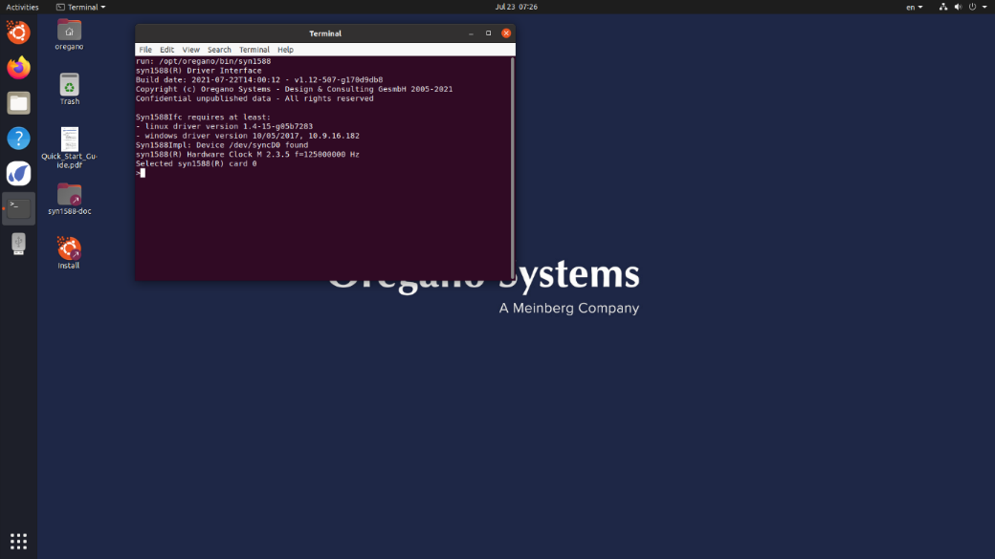

Figure 12 syn1588® Utility output

## Starting a syn1588® Shell

To start the syn1588® Shell click in the Syn1588 Launcher the “Syn1588 Shell” and then press “Run” (Figure 13). It will open a root shell with the working directory set to “/opt/oregano”(Figure 14).

This can be used to access the full feature-set of the syn1588® Software Suite applications that are located in this directory.



Figure 13 Select to run the syn1588® Utility

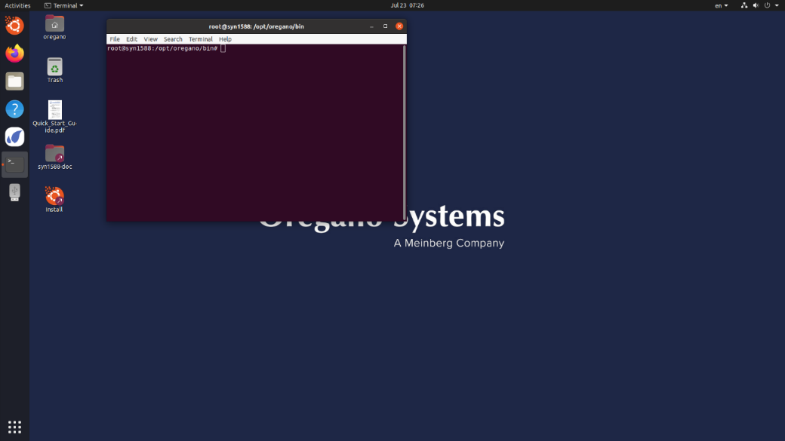

Figure 14 Syn1588 Shell terminal window

## Starting a syn1588® NIC Update GUI

To start the syn1588® NIC Update GUI select from the syn1588® Launcher the “Syn1588 NIC Update GUI” and then press “Run” (Figure 15). It will open a GUI application (Figure 16) that can be used to update the firmware of a syn1588® PCIe NIC or Dual NIC.  
Refer also to the user guide for this utility:  
🡪 (AN014)

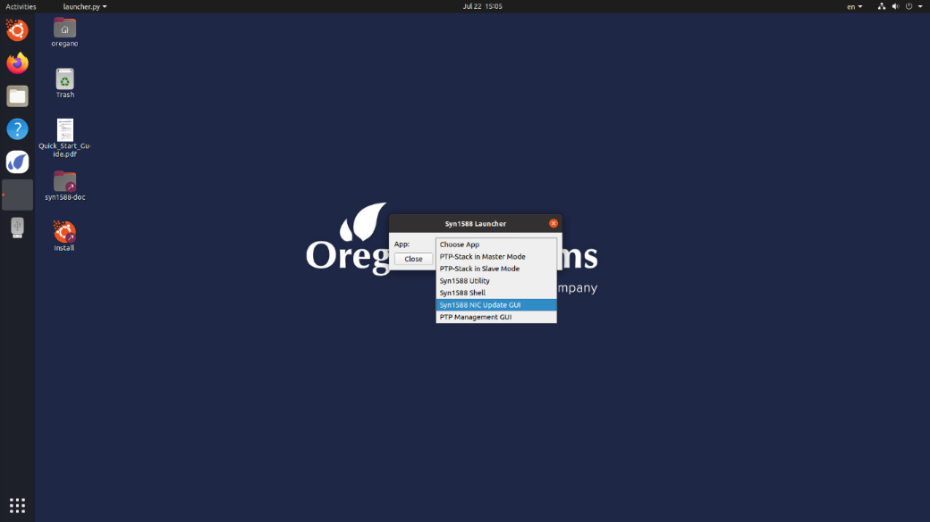

Figure 15 Select Syn1588 NIC Update GUI

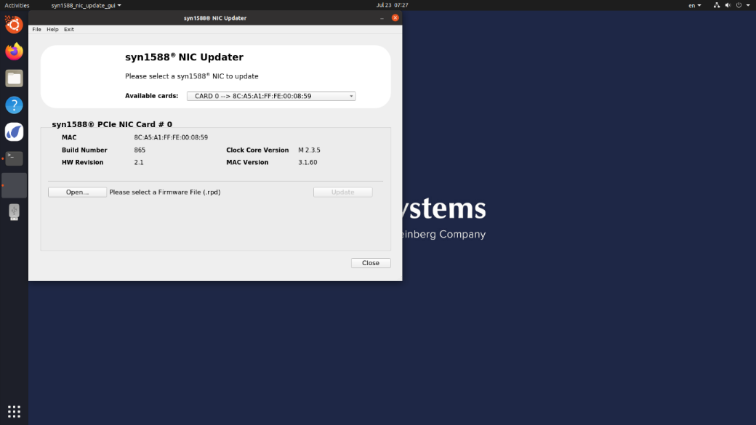

Figure 16 The GUI to update a syn1588® PCIe NIC

## Starting a syn1588® PTP Management GUI

To start a PTP Management GUI select the “PTP Management GUI” from the syn1588® Launcher and then press “Run” (Figure 17). It will open a graphic user interface from which the user is able to remotely monitor, configure, and control other PTP clock types like Ordinary Clocks or Boundary Clocks (Figure 18).  
Refer also to the user guide for this utility  
🡪 (UG002)

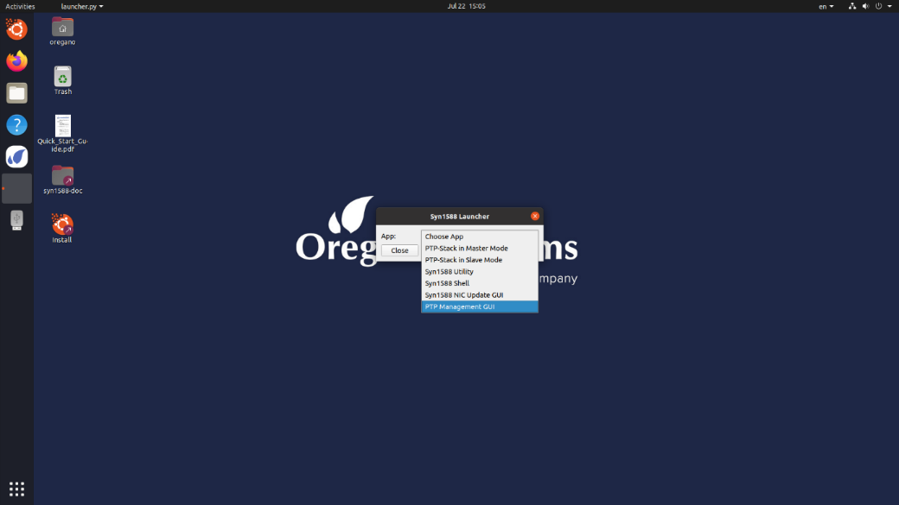

Figure 17 Select to run the PTP Management GUI

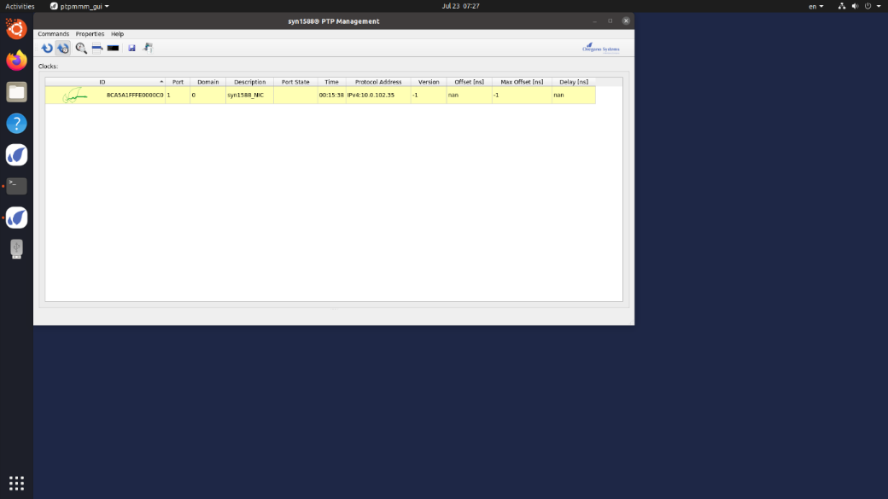

Figure 18 The PTP Management GUI window

## Changing the keyboard layout used in the syn1588® Linux Live System

To change the keyboard layout, follow the guide in this chapter.

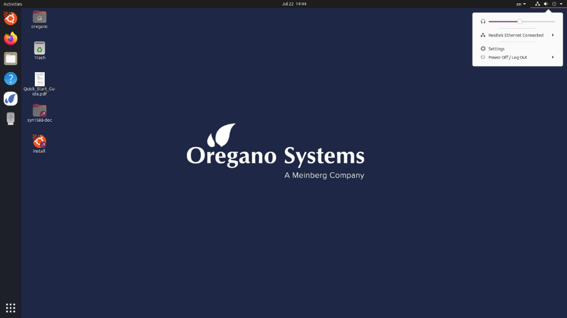

Figure 19 Click on the small arrow and select “Settings”

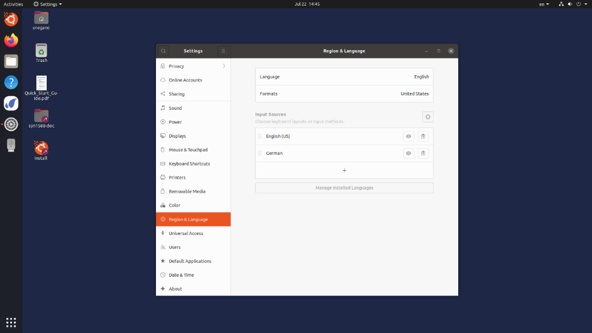

Figure 20 Click on Region & Languages and then on the “+” sign

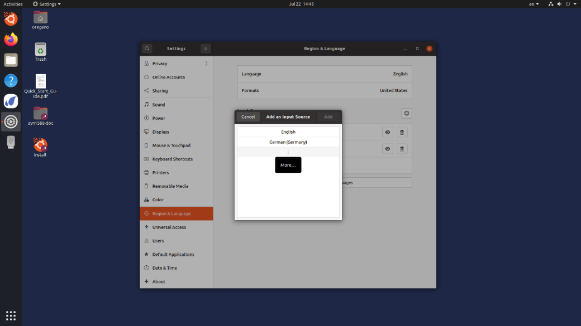

Figure 21 Click on the “three vertical dots” sign

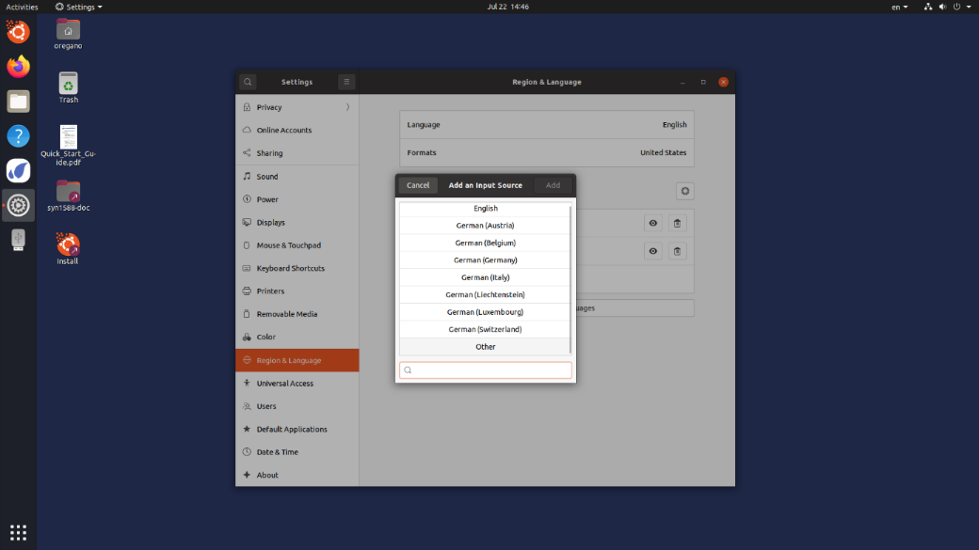

Figure 22 Type in the textbox the keyboard layout

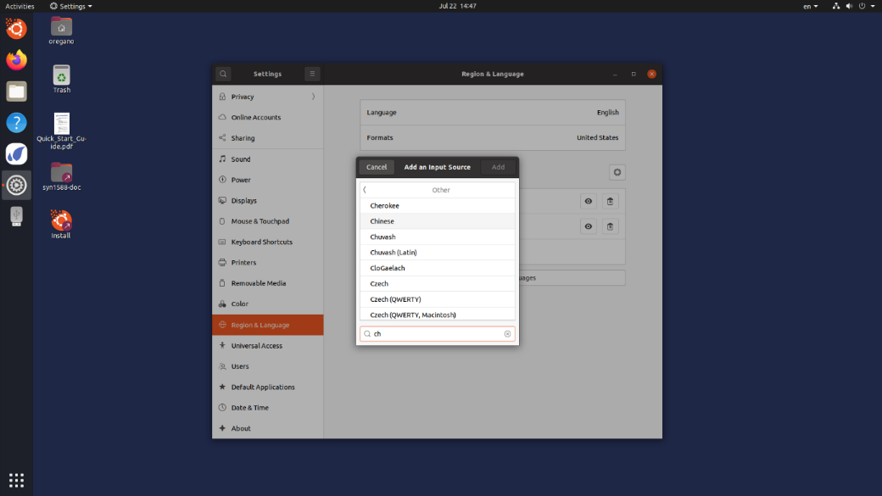

Figure 23 Choose from the scroll down the desired keyboard layout

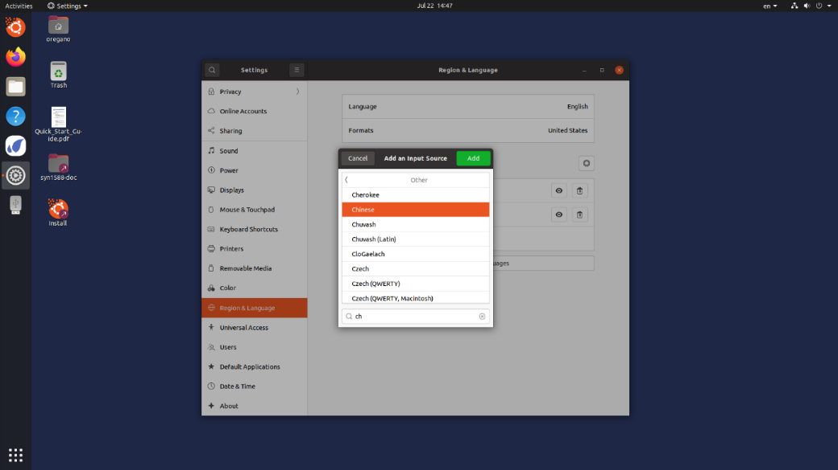

Figure 24 Click on “Add”

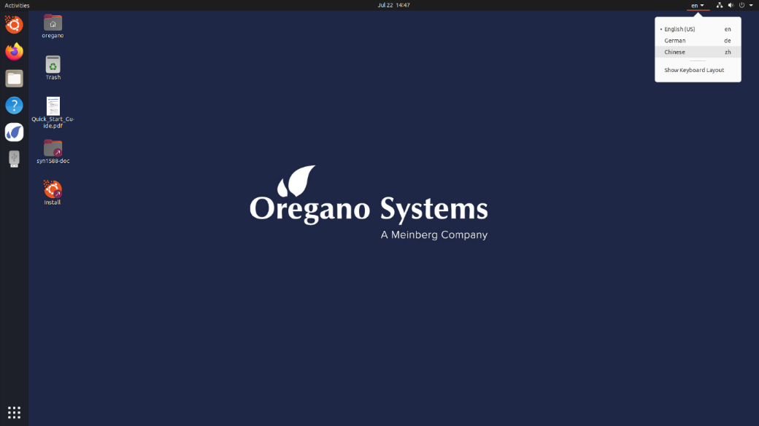

Figure 25 Click on the desired Keyboard Layout

# Literature

AN001. *Application Note: "syn1588® Clock M IP Core Register Map"*. Oregano Systems, Version 1.60 - April 2021.

AN004. *Application Note: "syn1588® PCIe NIC - Quick Start Guide"*. Oregano Systems, Version 1.13.1 - July 2021.

AN005. *Application Note: "syn1588® System Information Report"*. Oregano Systems, Version 1.13.0 - July 2021.

AN006. *Application Note: "syn1588® & PTP Profiles"*. Oregano Systems, Version 1.13.1 - July 2021.

AN007. *Application Note: "Using syn1588® Event I/Os"*. Oregano Systems, Version 1.13.0 - July 2021.

AN008. *Application Note: "Using the "frequency" and "extclk" command and the external jitter cleaner PLL of a syn1588® PCIe NIC or syn1588® VIP"*. Oregano Systems, Version 1.13.0 - July 2021.

AN009. *Application Note: "Recommended GPS Receivers for syn1588® Hardware tests"*. Oregano Systems, Version 1.13.0 - July 2021.

AN010. *Application Note: "Using the syn1588® NIC Video Add-on"*. Oregano Systems, Version 1.13.0 - July 2021.

AN014. *Application Note: "syn1588® NIC Updater"*. Oregano Systems, Version 1.13.0 - July 2021.

AN021. *Application Note: "Running the syn1588® PTP Stack as Windows Service"*. Oregano Systems, Version 1.13.0 - July 2021.

AN022. *Application Note: "PTPv2.1 Security"*. Oregano Systems, Version 1.13.0 - July 2021.

AN034. *Application Note: "Using redSync"*. Oregano Systems, Version 1.13.1 - July 2021.

AN037. *Application Note: "syn1588® PTP Stack Source Code CMake - Build Environment"*. Oregano Systems, Version 1.13.2 - July 2021.

AN038. *Application Note: "syn1588® Linux Life System Quickstart Guide"*. Oregano Systems, Version 1.13.1 - July 2021.

RN001. *Release Notes: "syn1588® Software Suite Release Overview"*. Oregano Systems, Version 1.13.7 - July 2021.

RN002. *Release Notes: "syn1588® Software Suite Release Roadmap"*. Oregano Systems, Version 1.13.2 - July 2021.

RN003. *Release Notes: "syn1588® Software Suite Release OS Support"*. Oregano Systems, Version 1.13.4 - July 2021.

RN004. *Release Notes: "syn1588® Software Suite Release Details"*. Oregano Systems, Version 1.13.6 - July 2021.

UG001. *User Guide: "syn1588® User Guide"*. Oregano Systems, Version 1.13.1 - July 2021.

UG002. *User Guide: "syn1588® PTP Management GUI"*. Version 1.13.0 - July 2021.

# Version history

Version 1.13.2 - September 2021  
Added sub-chapters in the “Installer” chapter

Version 1.13.1 - July 2021  
Added description for creating a bootable USB drive

Version 1.13.0 - July 2021  
Initial version

|  |  |
| --- | --- |
| Franzosengraben 8  A-1030 Vienna  Austria  <http://oregano.at>  [contact@oregano.at](mailto:contact@oregano.at) | Copyright © 2021  Oregano Systems – Design & Consulting GmbH  ALL RIGHTS RESERVED.  Oregano Systems does not assume any liability arising out of the application or use of any product described or shown herein nor does it convey any license under its patents, copyrights, or any rights of others.  Licenses or any other rights such as, but not limited to, patents, utility models, trademarks or tradenames, are neither granted nor conveyed by this document, nor does this document constitute any obligation of the disclosing party to grant or convey such rights to the receiving party.  Oregano Systems reserves the right to make changes, at any time without notice, in order to improve reliability, function or design. Oregano Systems will not assume responsibility for the use of any circuitry described herein.  All trademarks used in this document are the property of their respective owners. |