Abstract
This application note describes the process of running the Precision Time Protocol (PTP) as defined in IEEE 1588-2008 on a PC or server using a syn1588® PCIe NIC. It highlights the basic steps required to install and use the syn1588® PCIe NIC as well as references to the syn1588® User Guide (UG001) and other Application Notes.

Prerequisites
- A syn1588® PCIe NIC.
- A PC with a free PCIe slot.
- The wooden USB-Stick bundled with your syn1588® PCIe NIC containing the syn1588® PTP software and all accompanying drivers and documents within a syn1588® Linux Live System.
- In case the software is to be installed on an existing operating systems rather than using the syn1588® Linux Live System administrator rights are required.

What about the syn1588® Dual NIC
The basic installation procedure for the syn1588® Dual NIC is identical to the one for the syn1588® PCIe NIC. The main difference is that the syn1588® Dual NIC currently just supports Linux OS.

Basic Installation of the syn1588® PCIe NIC
To set up the syn1588® PCIe NIC please start with the following steps:
- Power off your PC.
- Insert the syn1588® PCIe NIC into an empty PCIe slot. Use an appropriate slot that supports PCIe x1 cards.
- Connect the syn1588® PCIe NIC to a network or to another PC using a standard Ethernet cable (or optical fiber in case of the SFP version of the syn1588® PCIe NIC).
There are two different ways of continuing: Either use the bootable syn1588® Linux Live System contained on the USB Stick provided with the syn1588® PCIe NIC or you could install the software together with the drivers onto an existing Windows/Linux PC. If there are any problems during the installation of the syn1588® PCIe NIC, please consult the syn1588® User Guide (UG001) at Chapter 4.4.

Using the syn1588® Linux Live System
The syn1588® Linux Live System starts a dedicated Linux (Ubuntu 20.04, 64 bit) with all drivers and utilities pre-installed. Please make sure, that the PC you are using is able to boot from an USB stick; you might have to check the BIOS settings for this.
Insert the USB stick into your computer and select the appropriate boot option. After the boot procedure has been completed successfully you will see an Ubuntu desktop. There are several icons on the desktop of the syn1588® Linux Live System. Refer to the Application Note (AN038) for more information about the syn1588® Linux Live System.

Installing the driver on your PC
The first step which has to be completed after powering up your PC is the installation of the device driver. Please note, that this step usually needs Administrator-Rights on Windows, or root-rights on Linux respectively.
There are tools to verify the proper operation of the syn1588® PCIe NIC hardware. This allows to deal with systems that behave somewhat different from standard systems. These tools can be found on the provided USB-Stick or other storage medium. If you are able to see an additional network adapter in the system you can proceed.

Installing the device driver in Linux
For a Linux operating system open a root shell, browse to the Linux driver-directory “/syn1588/sw” on the provided syn1588® USB Stick and execute:
> dpkg -i syn1588-dkms_<version>_all.deb
Note the <version> field holds the actual version of the current driver package.
E.g., for Release v1.13 the full file name is syn1588-dkms_1.13.1_all.deb.
After successful installation, the device driver has to be loaded using the following command:
> modprobe SyncDriver
If the device driver is updated, the old modules have to be removed from the memory.
> rmmod SyncDriver.ko
> rmmod syn1588nic.ko
After this step is completed load the new driver:
> modprobe SyncDriver
To verify if the device driver was successfully installed and loaded check Chapter Driver Check.

Installing the device driver in Windows
If not already prompted to install a new device, simply browse to the Control Panel and open the Device Manager. Select the new device, which may be listed as “unknown device” and update the drivers. Manually select “syn1588.inf” in the device driver folder “/syn1588/sw/windows_drv” on the provided syn1588® USB Stick. After successful installation, the syn1588® PCIe NIC should be listed at the section “network cards” in the Windows device manager or System Control. For troubleshooting or further information refer to (UG001) Chapter 4.4.2.

In case of installation issues
In case the installation procedure of the device driver software fails please check this chapter that describes how to fix frequently known issues.

Basic Presence Check of the syn1588® PCIe NIC
First step is to check for the presence of the syn1588® PCIe NIC in the device list of the computer. If this check fails the device is not recognized by the PC’s BIOS. Reasons for this are either an inappropriate PCIe slot or the card is not correctly inserted. Please power-off your PC prior checking the proper connection.

Linux
Run the command “lspci | grep Altera” from any terminal. The command shall return a line like the following:
> lspci | grep Altera
03:00.0 Ethernet controller: Altera Corporation Device 1000 (rev 03)
If the command returns no entry the BIOS had not recognized the syn1588® PCIe NIC. Check that the syn1588® PCIe NIC had been properly inserted in an appropriate PCIe slot.

Windows
Browse to the Control Panel and open the Device Manager. There should be a new network interface card listed for the syn1588® PCIe NIC. In rare cases the card shows up as an unknown device. If no such device is present the BIOS had not recognized the syn1588® PCIe NIC.

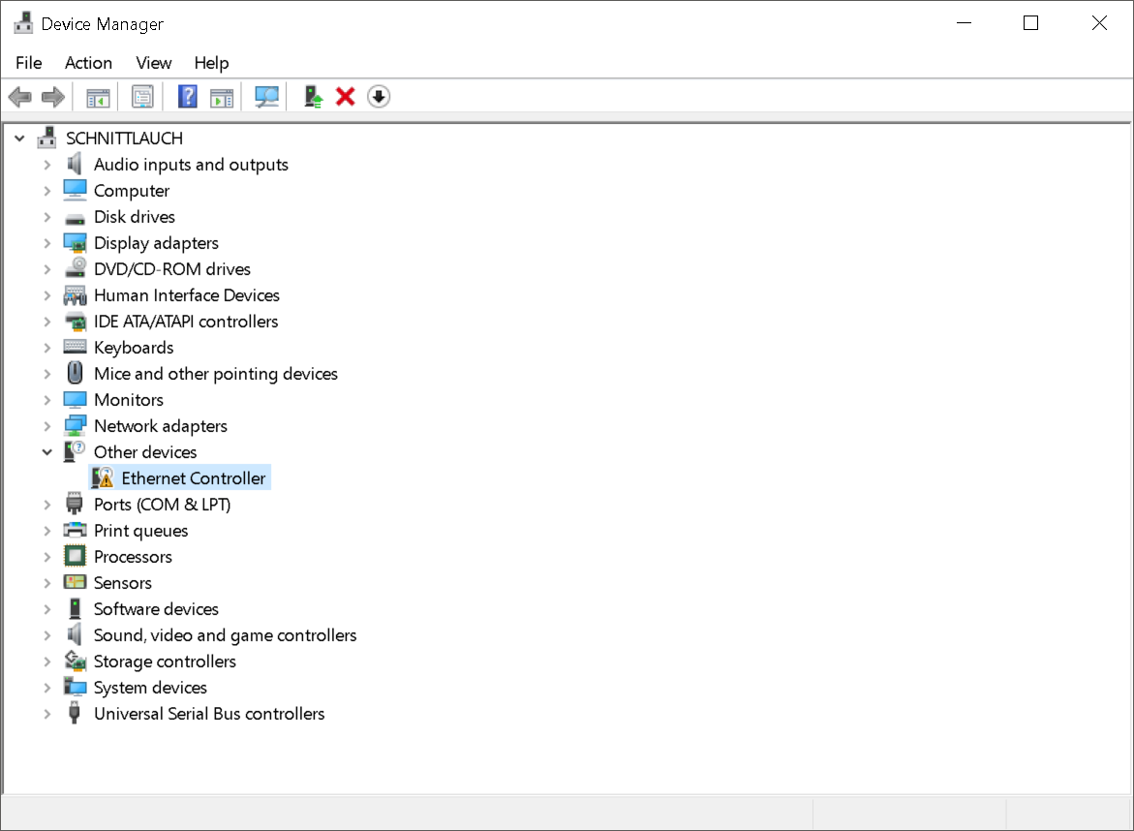
Figure 1: Device manager: Other Devices

Driver Check
If the syn1588® PCIe NIC had been successfully recognized by the PC’s BIOS one has to check whether the device driver had been successfully installed.

Linux
For Linux there are actually two device drivers that have to be loaded:
- syn1588nic
- SyncDriver
The “SyncDriver” has to be loaded after the “syn1588nic” driver. One can use the “lsmod” command to check for the presence of these drivers:
> lsmod |grep syn1588
syn1588nic 53248 1 SyncDriver
mii 16384 2 r8169,syn1588nic
> lsmod |grep Sync
SyncDriver 20480 0
syn1588nic 53248 1 SyncDriver

Manual driver installation from source
Extract the sources from the syn1588-dkms_<version>.tar.gz archive and navigate to the linux sub-directory.
> make modules_install
You may see the following or a similar output:
bash scripts/write_version.sh
tying to build driver with kernel source /lib/modules/5.4.0-77-generic/build
CC [M] /opt/oregano/syn1588_drv/syn1588-dkms_1.13.1.tar/linux/SyncDriver.o
CC [M] /opt/oregano /syn1588_drv/syn1588-dkms_1.13.1.tar/linux/syn1588nic_main.o
CC [M] /opt/oregano/syn1588_drv/syn1588-dkms_1.13.1.tar/linux/syn1588nic_pci.o
CC [M] /opt/oregano/syn1588_drv/syn1588-dkms_1.13.1.tar/linux/syn1588_debugfs.o
LD [M] /opt/oregano/syn1588_drv/syn1588-dkms_1.13.1.tar/linux/syn1588nic.o
Building modules, stage 2.
MODPOST 2 modules
CC [M] /opt/oregano/syn1588_drv/syn1588-dkms_1.13.1.tar/linux/SyncDriver.mod.o
LD [M] /opt/oregano/syn1588_drv/syn1588-dkms_1.13.1.tar/linux/SyncDriver.ko
CC [M] /opt/oregano/syn1588_drv/syn1588-dkms_1.13.1.tar/linux/syn1588nic.mod.o
LD [M] /opt/oregano/syn1588_drv/syn1588-dkms_1.13.1.tar/linux/syn1588nic.ko
INSTALL /mnt/user_puhm/puhm/design/syn1588_drv/syn1588-dkms_1.13.1.tar/linux/SyncDriver.ko
At main.c:160:
- SSL error:02001002:system library:fopen:No such file or directory: ../crypto/bio/bss_file.c:69
- SSL error:2006D080:BIO routines:BIO_new_file:no such file: ../crypto/bio/bss_file.c:76
sign-file: certs/signing_key.pem: No such file or directory
INSTALL /mnt/user_puhm/puhm/design/syn1588_drv/syn1588-dkms_1.13.1.tar/linux/syn1588nic.ko
At main.c:160:
- SSL error:02001002:system library:fopen:No such file or directory: ../crypto/bio/bss_file.c:69
- SSL error:2006D080:BIO routines:BIO_new_file:no such file: ../crypto/bio/bss_file.c:76
sign-file: certs/signing_key.pem: No such file or directory
DEPMOD 5.4.0-77-generic
Warning: modules_install: missing 'System.map' file. Skipping depmod.
depmod -b "/" -a 5.4.0-77-generic

Note, some Linux versions require a signed device driver. The “SSL errors” messages marked with red color in the example output above are caused by the fact that the driver is not signed or properly signed by the Linux OS which requires a signed driver. Follow the step-by-step instructions of the “README” file included in the driver directory to generate such a signed driver.
If the drivers had been successfully installed one can check the respective boot messages in the system log. For this enter the command “dmesg | grep syn1588”. One shall see that first the “syn1588nic” driver is loaded followed by the “SyncDriver”.
> dmesg |grep syn1588
[632300.852969] Oregano Systems syn1588(R) PCIe/Dual NIC Device Driver (syn1588nic) v1.13-5-g1095a2f
Copyright (C) 2006-2020 Oregano Systems - Design & Consulting GesmbH.
In cooperation with
Austrian Academy of Sciences, Institute for Integrated Sensor Systems
[632300.852985] syn1588nic: allocating device resources.
[632300.853116] syn1588nic: card has not valid, build
[632300.853122] syn1588nic: device resources (IRQ #16, I/O 0xF7200000 (65536)) detected.
[632300.853126] syn1588nic: Found a syn1588(R) PCIe NIC! bar0
[632300.853127] syn1588nic: registered syn1588(R) PCIe/Dual NIC adapter 0000:01:00.0.
[632300.853127] syn1588nic: Total adapters
[632300.853127] syn1588nic: nic_id: 0
[632300.853129] syn1588nic: PCI_DEV_INIT: Created DMA Memory Pool for adapter 0
[632300.853137] syn1588nic: Found MAC version 3160, build 865.
[632300.853137] syn1588nic: Found MAC with timestamper
[632300.853139] syn1588nic: Using burst lenght: 32
[632300.853143] syn1588nic: 0000:01:00.0: read permanent HW MAC address 00:1E:C0:F6:C7:3D
[632300.853145] syn1588nic: 0000:01:00.0: using MII managment data clock 500 kHz (div.: 50).
[632300.853711] syn1588nic: 0000:01:00.0: Marvell 88E1111 initialization sequence done.
[632300.853711] syn1588nic: 0000:01:00.0: detected PHY (0x01410CC2) with ID 0x00.
[632300.853925] syn1588nic: Set Passthrumask for adapter 0
[632300.853929] syn1588nic: Adapter Rev. 3 passthru mask: ff800000
[632300.853955] syn1588nic: NIC_DEV_INIT: Initializing 64 RX DMA buffers of size 2048 and startoff 0.
[632300.854160] syn1588nic: NIC_DEV_INIT: Initializing 64 TX DMA buffers of size 2048 and startoff 0.
[632300.854554] syn1588nic: eth0: Grp_list_head b00eec04
[632300.855642] syn1588nic: detected syn1588(R) Clock version M235.
[632300.855643] syn1588nic: ClockFreq: req_version 11, value 35
[632300.855646] syn1588nic: preparing device file.
[632300.855731] syn1588nic: device file csc0 setup (minor #58) complete.
[632300.855732] syn1588nic: configured clock frequency: 125000 kHz.
[632300.855732] syn1588nic: setting initial clock step size to 8.0 ns.
[632300.856175] syn1588nic 0000:01:00.0 enp1s0: renamed from eth0
[632300.856182] syn1588nic: detected syn1588(R) PCIe/Dual NIC revision 2.x (enp1s0/csc0).
[632300.856183] syn1588nic: internal rev id: 3 - 3
[632300.856183] syn1588nic: PCI_DEV_INIT: This is a syn1588(R) PCIe/Dual NIC Rev 2, programming DAC
[632300.856258] syn1588nic: allocating device resources.
[632300.856460] syn1588nic: card has not valid, build
[632300.856468] syn1588nic: device resources (IRQ #17, I/O 0xF7100000 (65536)) detected.
[632300.856473] syn1588nic: Found a syn1588(R) PCIe NIC! bar0
[632300.856474] syn1588nic: registered syn1588(R) PCIe/Dual NIC adapter 0000:02:00.0.
[632300.856474] syn1588nic: Total adapters
[632300.856474] syn1588nic: nic_id: 0
[632300.856475] syn1588nic: nic_id: 0
[632300.856478] syn1588nic: PCI_DEV_INIT: Created DMA Memory Pool for adapter 0
[632300.856487] syn1588nic: Found MAC version 3160, build 865.
[632300.856487] syn1588nic: Found MAC with timestamper
[632300.856489] syn1588nic: Using burst lenght: 32
[632300.856494] syn1588nic: 0000:02:00.0: read permanent HW MAC address 00:1E:C0:85:D0:0C
[632300.856496] syn1588nic: 0000:02:00.0: using MII managment data clock 500 kHz (div.: 50).
[632300.856712] syn1588nic: 0000:02:00.0: detected PHY (0x00221622) with ID 0x00.
[632300.856935] syn1588nic: Set Passthrumask for adapter 0
[632300.856939] syn1588nic: Adapter Rev. 3 passthru mask: ff800000
[632300.856970] syn1588nic: NIC_DEV_INIT: Initializing 64 RX DMA buffers of size 2048 and startoff 0.
[632300.857186] syn1588nic: NIC_DEV_INIT: Initializing 64 TX DMA buffers of size 2048 and startoff 0.
[632300.889224] syn1588nic: eth0: Grp_list_head 95e2158c
[632300.889227] syn1588nic: detected syn1588(R) Clock version M235.
[632300.889228] syn1588nic: ClockFreq: req_version 11, value 35
[632300.889232] syn1588nic: preparing device file.
[632300.889295] syn1588nic: device file csc1 setup (minor #57) complete.
[632300.889295] syn1588nic: configured clock frequency: 125000 kHz.
[632300.889296] syn1588nic: setting initial clock step size to 8.0 ns.
[632300.889795] syn1588nic: detected syn1588(R) PCIe/Dual NIC revision 2.x (eth0/csc1).
[632300.889796] syn1588nic: internal rev id: 3 - 3
[632300.889796] syn1588nic: PCI_DEV_INIT: This is a syn1588(R) PCIe/Dual NIC Rev 2, programming DAC
[632300.890379] Oregano Systems syn1588(R) Clock Synchronization Driver (SyncD) v1.13-5-g1095a2f
Copyright (C) 2006-2020 Oregano Systems - Design & Consulting GesmbH
In cooperation with
Austrian Academy of Sciences, Institute for Integrated Sensor Systems
[632300.890387] syn1588nic: device callback (0x00000000a9927b0e) registered.
[632300.890390] SyncD: preparing device file.
[632300.890476] SyncD: device file syncD0 setup (minor #56) for device handle 0x000000009e45e97b complete.
[632300.890477] SyncD: preparing device file.
[632300.890513] SyncD: device file syncD1 setup (minor #55) for device handle 0x00000000083cecc0 complete.
[632300.898694] syn1588nic 0000:02:00.0 enp2s0: renamed from eth0
[632300.947500] syn1588nic 0000:01:00.0 enp1s0: link up, 1000Mbps, full-duplex, lpa 0xC1E1
[632300.965260] syn1588nic 0000:02:00.0 enp2s0: link up, 1000Mbps, full-duplex, lpa 0xC1E1

Windows
In case the device is not visible first right click on network adapters and scan for hardware changes. A new network adapter named “SYN1588 PCIe Ethernet Adapter” shall appear.
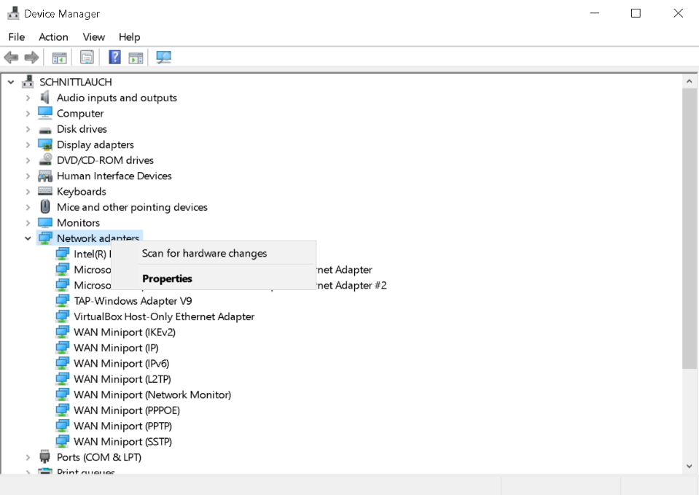
Figure 2: Device manager: scan for network adapters
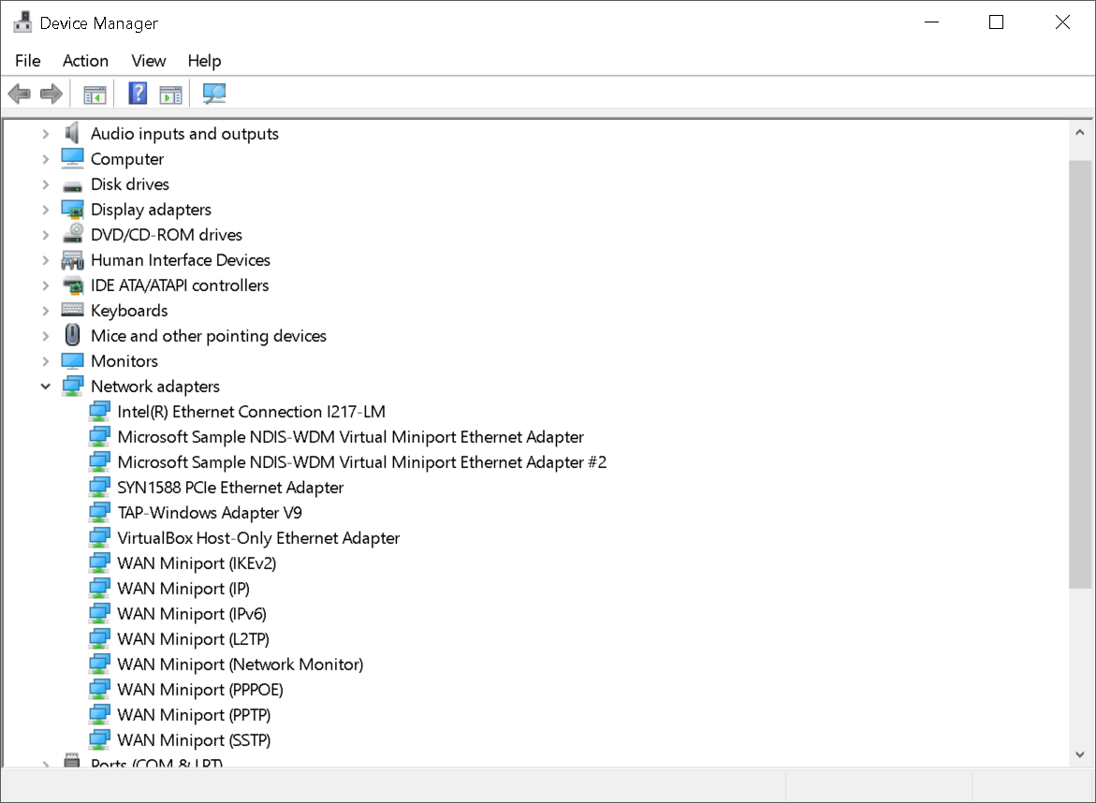
Figure 2.1: Device manager: new network adapter

To access more information or update the device driver travel to the menu “Properties” and in the dialog box select the “Driver” tab. Under this section one can select “Driver Details” to find out more details about the installed driver files or to “Update Driver” to update the installed device driver.
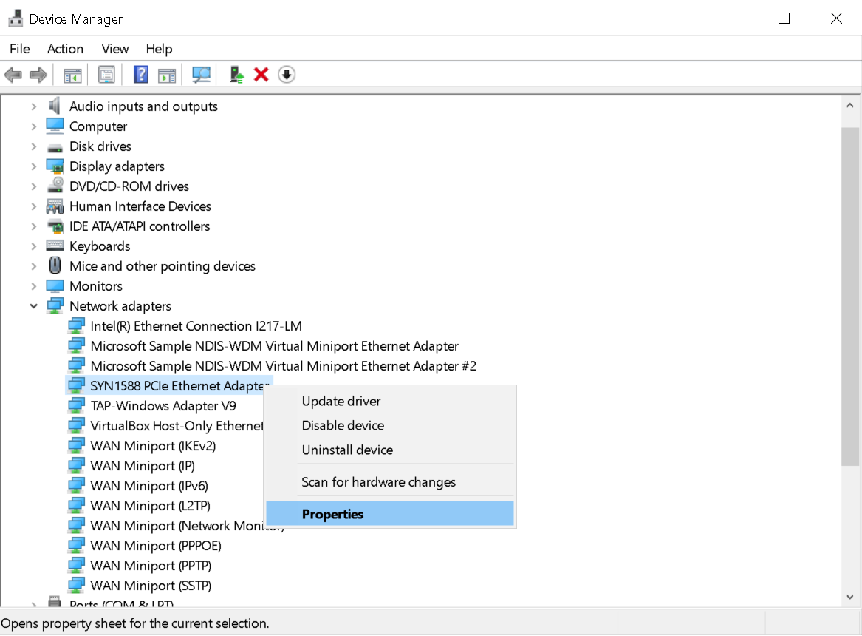
Figure 2.2: Device manager: syn1588® PCIe NIC
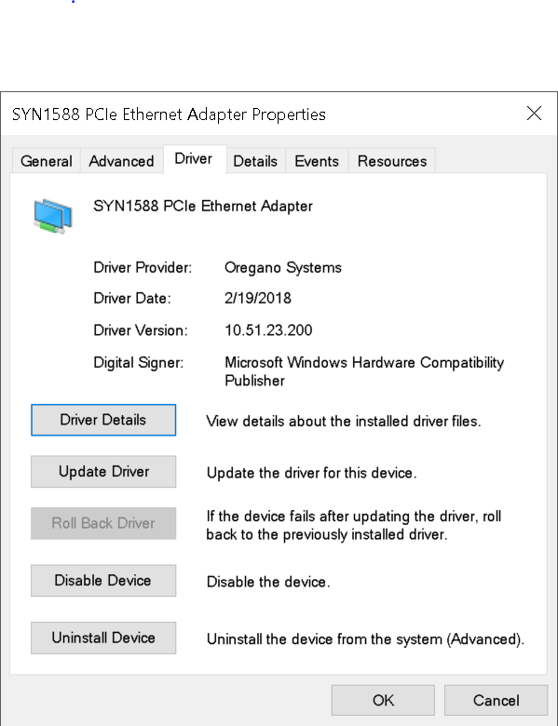
Figure 2.3: syn1588® PCIe NIC: Properties
An alternate way to check if the driver had been installed, is to enter in the command prompt the command “driverquery | findstr syn1588”.No administrator rights are needed. This should bring up the syn1588® driver installed on the system.
> driverquery | findstr syn1588
Module Name Display Name Driver Type Link Date
============ ====================== ============= ==========
syn1588 SYN1588 PCIe Ethernet Kernel 2/19/2018 10:51:12 AM
If this output message is not received, the installation of the driver was not successful. Please re-install the driver as shown in the previous steps or refer to the tutorial How to install a driver in Windows for a syn1588® PCIe NIC.

First Steps with your installed syn1588® PCIe NIC
The easiest way to use the syn1588® PTP Stack and other tools is the command line or shell. Please ensure your shell-session has sufficient rights. For Windows an administrator-command line, and for Linux a root-shell is recommended.
As a first step you need to ensure that the syn1588® PCIe NIC has a valid IP-address assigned to it either via DHCP or manual configuration. For Windows write down this IP-address (i.e. 192.168.0.123) for further reference. For Linux you require the adapter name (i.e. eth3).

Starting the syn1588 Utility
The syn1588 utility is used to control and check several functions of the syn1588® PCIe NIC. For more information about the syn1588 Utility please refer to the syn1588® User Guide (UG001) Chapter 7.1.

syn1588® Linux Live System
> cd /opt/oregano/bin
> ./syn1588
The output of the syn1588 Utility on Linux will look like this example output:
syn1588(R) Driver Interface
Build date: 2021-07-27T10:11:53 - v1.13-27-g03bec48b
Copyright (c) Oregano Systems - Design & Consulting GesmbH 2005-2021
Confidential unpublished data - All rights reserved

Syn1588Ifc requires at least:
- linux driver version 1.4-15-g05b7283
- windows driver version 10/05/2017, 10.9.16.182
Syn1588Impl: Device /dev/syncD0 found
syn1588(R) Hardware Clock M 2.3.4 f=125000000 Hz
Selected syn1588(R) card 0
>

Version and status information about the tool and your syn1588® PCIe NIC is shown, if everything was set up correctly. Additionally, one may enter the command “build” on the prompt of the syn1588 Utility to get even more information on the syn1588® PCIe NIC.
If any problems occur, please ensure the previous steps were completed successfully.

The syn1588 Software Suite is delivered in ready-to-use installers for Linux and Windows systems. For more information about custom installation please refer to the (AN038) Chapter “Installer”.

Linux Custom Installation
As default the syn1588 Software Suite is installed in /opt/oregano/. To start the syn1588 Utility go to the bin folder and start the application as shown.
> cd /opt/oregano/bin
> ./syn1588
The output of the syn1588 Utility on Linux will look like the example above.

Windows Custom Installation
To start the syn1588 Utility go to the chosen location where the Syn1588 Software Suite is installed. The bin folder contains the application binaries including the syn1588 Utility.
> cd <chosen location>\bin
> syn1588.exe
The output of the syn1588 Utility on Windows will look like this example output:
syn1588(R) Driver Interface
Build date: 2021-07-27T10:11:53 - v1.13-27-g03bec48b
Copyright (c) Oregano Systems - Design & Consulting GesmbH 2005-2021
Confidential unpublished data - All rights reserved

Syn1588Ifc requires at least:
- linux driver version 1.4-15-g05b7283
- windows driver version 10/05/2017, 10.9.16.182
syn1588(R) Hardware Clock M 2.3.4 f=125000000 Hz
Selected syn1588(R) card 0

Starting the syn1588® PTP Stack
The syn1588® PTP Stack is a lightweight Precision Time Protocol stack which enables highly accurate clock synchronization in local area networks. For more information about the syn1588® PTP Stack please refer to the syn1588® User Guide (UG001) Chapter 6.
To start your PC as a PTP node, run the syn1588® PTP Stack as follows. Please change the IP-address or interface name accordingly to your system settings.

Linux Live System
> cd /opt/oregano/bin
> ./ptp –i eth3 –v2
The first part of the output on Linux will look like this example output:
syn1588(R) PTP Stack - IEEE1588-2008 Engine
Build date: 2021-07-27T10 - V 1.13-27-g03bec48b
Copyright (c) Oregano Systems - Design & Consulting GesmbH 2005-2021
Confidential unpublished data - All rights reserved

syn1588(R) PTP Stack started: 2021-09-08 13:02:51.388112 (UTC)
Port 1: adding config "i" = "eth3"
Port 1: adding config "v" = "2"
Command line: ./ptp -i eth3 -v 2
(1) Found Configuration for 1 ports
(1) Syn1588Ifc requires at least:
- linux driver version 1.4-15-g05b7283
- windows driver version 10/05/2017, 10.9.16.182
(1) Syn1588Impl: Device /dev/syncD0 found
(1) syn1588(R) Hardware Clock M 2.3.5 f=125000000 Hz
(1) syn1588(R) PCIe NIC Revision 2.1, Build 865 with HQ Oscillator
(1) Board revision 2.1.1.0
(1) Serial: 011903852
(1) Using syn1588 mode
(1) read to NULL pointer ignored!
(1) Activated SO_TIMESTAMPING hardware
(1) Activated SO_TIMESTAMPING hardware
(1) Clk: Using Oregano Systems; syn1588(R) PCIe NIC Revision 2.1; 8C:A5:A1:00:05:16
(1) with ClockId 8C:A5:A1:FF:FE:00:05:16
(1) Clk: Resetting servos
……….

Linux Custom Installation
As default the syn1588 Software Suite is installed in /opt/oregano/. To start the syn1588 PTP Stack go to the bin folder and start the application as shown.
> cd /opt/oregano/bin
> ./ptp –i eth3 –v2

Windows Custom Installation
To start the syn1588 PTP Stack go to the chosen location where the Syn1588 Software Suite is installed. The bin folder contains the application binaries including the syn1588 PTP Stack.
> cd <chosen location>\bin
> ptp.exe –i 192.168.0.123 –v2

FAQ, Caveats, and Common Traps and Pitfalls
- For a list of supported operating systems please consult the syn1588_release_OS_support document found in the syn1588 Linux Live System together with this document.
- Please ensure, that your syn1588® PCIe NIC has an IP-address assigned. Check also for correct setting of the subnet mask, gateway IP address and DNS server.
- Check, if the IP-address set does not interfere with other IP-addresses on the same machine or in the network. Ideally a separated subnet should be assigned to all syn1588® PTP devices at least during initial testing.
- On all operating systems the syn1588® PTP Stack requires root-privileges to run correctly.
- Check, if the firewall blocks any PTP traffic. PTP (in layer 3 mode) communicates via IP/UDP port 319 and 320. Please make sure that these ports are not blocked by your firewall.
- Simple way to check the configured IP address and functioning of hardware and/or software is to ping another host IP address. Also Wireshark can be used to check if the packets are received/transmitted at the configured network interface.
- If there are difficulties in using the syn1588® hardware and/or software, generate a system information report as specified in this Application Note (AN005). Collect the syn1588® System Information Report and send it to us for further support.

Literature
AN005. Application Note: "syn1588® System Information Report". Oregano Systems, Version 1.13.0 - July 2021.
AN038. Application Note: "syn1588® Linux Life System Quickstart Guide". Oregano Systems, Version 1.13.2- September 2021.
UG001. User Guide: "syn1588® User Guide". Oregano Systems, Version 1.13.1 - July 2021.

Franzosengraben 8  A-1030 Vienna  Austria  http://oregano.at  contact@oregano.at | Copyright © 2021  Oregano Systems – Design & Consulting GmbH  ALL RIGHTS RESERVED.  Oregano Systems does not assume any liability arising out of the application or use of any product described or shown herein nor does it convey any license under its patents, copyrights, or any rights of others.  Licenses or any other rights such as, but not limited to, patents, utility models, trademarks or tradenames, are neither granted nor conveyed by this document, nor does this document constitute any obligation of the disclosing party to grant or convey such rights to the receiving party.  Oregano Systems reserves the right to make changes, at any time without notice, in order to improve reliability, function or design. Oregano Systems will not assume responsibility for the use of any circuitry described herein.  All trademarks used in this document are the property of their respective owners.

